Multi-room Call for Heat

I have a number of Danfoss LC-13 valves around the house, together with a Secure SSR302 to turn the boiler on and off. The Danfoss valves are controlled by the Heating Panels, and I also have a Fibaro multi-sensor in each room. I've noticed from a number of posts on the forum that there are other people with the same or similar setup, and need a scene to control the boiler switch. The idea being that if any room needs heat, then the boiler will be turned on, and once all the rooms have reached the required temperature, then the boiler will be turned off.

Setup required:

Modify the device id for the Secure SSR302 (or whatever device is used to control the boiler) here:
local boilerSwitch = 84
You might also want to tweak this value:
local threshold = 0.3
This is used to build in some hysteresis into the system to prevent the boiler from being switched on and off too frequently. The boiler won't switch on until the temperature has dropped below the target temperature by this value or more.

The scene is triggered by a global 'timer' variable to run every 5 minutes. There are a number of timer scenes on the forum, but this is the scene that I use.

You should also change your Danfoss valves so that the Wake Up Interval is 300 seconds. I find that this doesn't have a detrimental effect on the battery but allows the devices to respond more quickly to the temperature change requests.

The scene works off the temperature sensor and thermostat that have been defined in your Room settings, so ensure that these are correct:

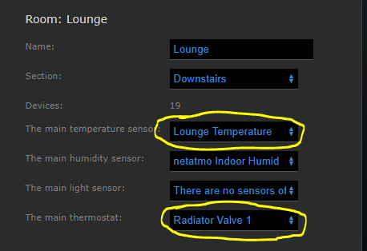

Note that this method of controlling the boiler assumes that your temperature sensors are working to the same temperatures as your Danfoss valves - ie: the Danfoss valves turn off once they've reached the target temperature, and that the temperature sensors are also reading this same value. You may need to tweak the temperature offset for the temperature sensors so that the two devices are in sync with each other. If in doubt then set the temperature offset so that the sensors read a slightly higher temperature. That way, the scene will think that the room has reached the desired temperature and turn off the boiler. Otherwise you may find that the boiler is not switching off because the room has reached the target temperature, but the Danfoss valve has already turned itself off.

Other types of boiler switch might not use the 'mode' property to determine whether they are on or off. Consequently, the following line may need to be changed, for example to use the 'value' property instead of 'mode':
local boilerOn = (fibaro:getValue(boilerSwitch, "mode") == "1")

Side topic:

Note that there is a school of thought that boilers should be left on all the time even if there aren't any rooms that require the heat, and that the boiler's control logic will detect this and modulate the water temperature accordingly. I don't necessarily uphold this view, but then I'm not a heating engineer either, so I'm happy to be persuaded either way. In my case, I believe that my condensing boiler operates most efficiently when there is a 20C difference between the output and input water temperatures, and as a result it needs the radiators to be drawing heat from the system. I also have radiators that aren't controlled by Danfoss valves (bathrooms and other small rooms), and I don't want to be heating them all the time, wasting energy. After all, the whole point of the Danfoss valves is to avoid having to heat rooms that you're not using, and thereby save some money. Maybe the more intelligent boilers that can regulate the water temperature according to the system's needs and outside temperature operate differently, and as a result more efficiently, and can be left on all the time. The general opinion, in the UK at least, appears to be that the heating should be turned off if not needed. Just my tuppence worth, but I know that views like this can be contentious so please don't shoot me down in flames.

As another side topic, it looks as though the new Fibaro TRVs are far superior to the Danfoss TRVs with the built in algorithms and the ability to cooperate with another sensor in the room. They should certainly avoid a lot of the problems that we get with the Danfoss valves. Pity I can't justify replacing them.

- Submitter
Dave Harrison
- Submitted
02/09/18
- Category
Scenes

Edited December 3, 2017 by Dave Harrison
Removed reference to boilerOnTime global variable, left in by mistake.
- adyboss
- 1

- Quote

Marjomar
- Newbie
- 

- 
- 0
- 17 posts
- Spain
- Gateway/s: Home Center 2

Posted December 3, 2017
Hi Dave,

Thanks for this great article. Please advice if you add any interesting feature to the code. By my side I only add to get the difference value ".. asterisk(belowThreshold) ..(roomTemp - roomSetpoint))"

Looks the behavior is faster that the other LUA code I use to have.

The only thing I´m missing and probably could be a challenge for you is to add the posibility to control the fast dropdown temperature due to open windows.

Thanks again for the article.
Sorry Dave,

I gorgot to ask you.

Where I can check this records?

On the event panel I can´t see it.

Thanks
-- Record the time that the boiler is turned on, so that we can monitor
-- whether it is being turned off in the Heating Monitoring scene
fibaro:setGlobal("boilerOnTime", os.time())
end

- Quote
HC2 since Jan 2015 ....

Dave_H
- Learner
- 
- Topic Author
- 
- 50
- 158 posts
- UK
- Gateway/s: Home Center 2
- Author

Posted December 3, 2017
On 12/3/2017 at 9:29 AM, Marjomar said:

-- Record the time that the boiler is turned on, so that we can monitor
-- whether it is being turned off in the Heating Monitoring scene
fibaro:setGlobal("boilerOnTime", os.time())
end

Hi @Marjomar

Sorry I left this bit in the scene by mistake...it's referencing a global variable which I use in another scene. It's not part of this solution, and so I've now taken it out.

For a scene to turn off the heating when a window is opened, and you have switches on your windows, then take a look at this post. If you haven't got window switches, then it's a bit more difficult, as you say. You would have to monitor for a rapid drop in temperature, but not impossible to do.

Dave

- Quote
- 1 month later...

adyboss
- Learner
- 
- 11
- 119 posts
- Romania
- Gateway/s: Home Center 2

Posted January 11, 2018
Hi Dave,
Thank you for sharing this scene. It is great.
Do you believe you can add "a new feature"?
What is about...?

For example, what I have is the following:

- three rooms - Living Room, Bedroom and Kids Room
- central heating with gas (I can have any relay there)
- Danfoss RS-Z Room Thermostat in each room (one per room)
- Danfoss Living Connect Z Radiator Thermostat on each radiator in each room (one per room)
- Fibaro HC2 (of course)

What I need is to have a scheduled heating in each room.
For example:
- From 21.00 to 06.00 to have 20 Celsius in Bedroom (20 C in Kids Room) and 17 Celsius in Living Room
- From 06.00 to 21.00 to have 23 Celsius in Living Room and 18.00 in Bedroom (and Kids Room)

- If I am in bed, is no need for the Living Room to be heated and the Danfoss LC Radiator Thermostat will close the valve there (no hot water in radiator).
- If I change the temperature from a "Danfoss RS-Z Room Thermostat" device, the scheme will be changed for that Room (override) until the next schedule time (21.00 or 06.00, depending when I am doing it)
- If I have set to 23 Celsius in all rooms, the system will heat until 23 will be achieved in all rooms but not more than 23 Celsius (I know, approximate over) in any room (closing radiator valves)

So, I am imagine that the system will read temperature from "Danfoss RS-Z Room Thermostat", and will send command to "Danfoss Living Connect Z Radiator Thermostat" (and of course to the gas central).
My main problem is to implement the "Room Thermostats" in scheme in order to change the temperature at my disposal (override). Of course, a full code will be better...

Regards,
Adrian.

- Quote

Dave_H
- Learner
- Topic Author
- 50
- 158 posts
- UK
- Gateway/s: Home Center 2
- Author

Posted January 12, 2018
Hi Adrian

It doesn't seem that Fibaro hasn't implemented anything to allow room thermostats to perform an override of the heating panel associated with that room. I've been meaning to create a scene that will do this for some time, as I have a Secure SRT321 thermostat that does nothing at the moment other than to report the room temperature. Changing the set point on the thermostat doesn't do anything, so your request has given me the urge to do something about it .

In theory you should be able to create a direct association between the Danfoss RS-Z Room thermostat and the Danfoss Living Connect Z Radiator Thermostat in that room to send the new set point to the radiator. However, I've tried this with my Secure SRT321 thermostat and it doesn't seem to work. Maybe I did something wrong...I don't find associations very intuitive.

I'll try to work on something over the weekend.

Dave

- Quote

adyboss
- Learner
- 11
- 119 posts
- Romania
- Gateway/s: Home Center 2

Posted January 12, 2018 (edited)
I don't know if I have to say that I'm sorry to "send" you at work or... I am happy
Regarding direct association, don't you think the heating panel should be "informed" about the override?

Do you think Fibaro's radiator thermostats (and its room temperature sensor) can work better on this scheme?
Edited January 12, 2018 by adyboss

- Quote

Dave_H
- Learner
- Topic Author
- 50
- 158 posts
- UK
- Gateway/s: Home Center 2
- Author

Posted January 12, 2018
Yes, my plan would be that changing the room thermostat would override the heating panel. The heating panel will then communicate with the radiator valves. This way, the override will be visible in the heating panel, and so would be visible on my Heating Override Virtual Device. With a direct association, the override would only be visible on the radiator valves.

- Quote
- 2 weeks later...

adyboss
- Learner
- 11
- 119 posts
- Romania
- Gateway/s: Home Center 2

Posted January 25, 2018
Hi @Dave Harrison,
I am running your scenes and VDes smoothly but unfortunately I still have problems with making everything to run properly.
Can you please take a peek here and tell me your opinion?
Thank you in advance.

- Quote
- 2 weeks later...

Dave_H
- Learner
- Topic Author
- 50
- 158 posts
- UK
- Gateway/s: Home Center 2
- Author
- Featured Comment

Posted February 9, 2018

Multi-room Call for Heat

I have a number of Danfoss LC-13 valves around the house, together with a Secure SSR302 to turn the boiler on and off. The Danfoss valves are controlled by the Heating Panels, and I also have a Fibaro multi-sensor in each room. I've noticed from a number of posts on the forum that there are other people with the same or similar setup, and need a scene to control the boiler switch. The idea being that if any room needs heat, then the boiler will be turned on, and once all the rooms have reached the required temperature, then the boiler will be turned off.

LUA CODE:
--[[
%% properties
%% events
%% globals
fiveMinuteTimer
--]]

-- Scene : Call For Heat Scene
-- Version : 1.0
-- Date Created : 28 February 2016
-- Last Changed : 10 September 2017
-- Created By : Dave Harrison

-- Purpose : To turn on the boiler whenever a room needs heat
-- Trigger : Triggered by the Timer Scene updating the fiveMinuteTimer global variable

-------------------- Declaration: Local Variables
local boilerSwitch = 84

-- Amount by which temperature needs to fall below setpoint before turning heating on
local threshold = 0.3

local sourceTrigger = fibaro:getSourceTrigger()
local currentDate = os.date("%d/%m/%Y %X")
local currentDateTime = os.date("*t")

-------------------- Functions

-- getRoomsAndDevices
---------------------
-- Get the list of rooms and devices to monitor
-- Only rooms with both a thermostat and thermometer will be selected
function getRoomsAndDevices()

local rooms = {}

local allRooms = api.get("/rooms")

for k, room in pairs(allRooms) do

local thermostat = room.defaultThermostat
local thermometer = room.defaultSensors.temperature

if (thermostat ~= nil and thermometer ~= nil) then
if (thermostat ~= 0 and thermometer ~= 0) then

-- Ignore any rooms where the thermostat doesn't have a value
if (tonumber(fibaro:getValue(thermostat, "value")) > 0) then
local newRoom = {id = room.id, name = room.name, thermostat = thermostat, thermometer = thermometer}
table.insert(rooms, newRoom)
end
end
end
end

return rooms
end

-- asterisk
-----------
-- Output an asterisk if true
function asterisk(condition)
local asterisk = ""

if (condition) then
asterisk = " *"
end

return asterisk
end

-------------------- Main
-- fibaro:debug(">> Trigger Type: " .. sourceTrigger.type)

if (sourceTrigger.name ~= nil) then
-- fibaro:debug(">> Trigger Name: " .. sourceTrigger.name)
end

-- Get the rooms and devices that we want to monitor
local rooms = getRoomsAndDevices()

-- Is the heating already on?
local boilerOn = (fibaro:getValue(boilerSwitch, "mode") == "1")
fibaro:debug(currentDate .. " Boiler on: " .. tostring(boilerOn))

local turnBoilerOn = false
local turnBoilerOff = true

-- Check each room
for i , room in pairs(rooms) do

local roomTemp = tonumber(fibaro:getValue(room.thermometer, "value"))
local roomSetpoint = tonumber(fibaro:getValue(room.thermostat, "targetLevel"))

-- Has the temperature fallen below setpoint by more than the threshold?
local belowThreshold = roomTemp <= (roomSetpoint - threshold)

fibaro:debug(">> Room: " .. room.name .. " Temperature: " .. roomTemp .. " Set Point: " .. roomSetpoint .. asterisk(belowThreshold))

-- If the boiler is not on, then check if any rooms need heat
if (not boilerOn) then

-- Need to turn the boiler on?
if (belowThreshold) then
turnBoilerOn = true
end
end

-- If the boiler is on, then check whether any rooms still need heat
if (boilerOn) then

-- Is the temperature still below the setpoint?
if (roomTemp < roomSetpoint) then
turnBoilerOff = false
end
end
end

-- Turn the boiler on?
if (not boilerOn and turnBoilerOn) then
fibaro:debug("*** Turning on heating")
fibaro:call(boilerSwitch, "setMode", "1")
end

if (not boilerOn and not turnBoilerOn) then
fibaro:debug("*** Keep heating off")
end

-- Turn the boiler off?
if (boilerOn and turnBoilerOff) then
fibaro:debug("*** Turning off heating")
fibaro:call(boilerSwitch, "setMode", "0")
end

-- The SSR302 boiler controller has a fail safe mode. If there has been no communication and the boiler channel is turned on
-- then it will go into fail safe mode after 60 minutes. Therefore, during the on-period, we need to resend the on message periodically.
if (boilerOn and not turnBoilerOff) then
fibaro:debug("*** Keep heating on")
fibaro:call(boilerSwitch, "setMode", "1")
end

Setup required:

Modify the device id for the Secure SSR302 (or whatever device is used to control the boiler) here:
local boilerSwitch = 84
You might also want to tweak this value:
local threshold = 0.3
This is used to build in some hysteresis into the system to prevent the boiler from being switched on and off too frequently. The boiler won't switch on until the temperature has dropped below the target temperature by this value or more.

The scene is triggered by a global 'timer' variable to run every 5 minutes. There are a number of timer scenes on the forum, but this is the scene that I use.

You should also change your Danfoss valves so that the Wake Up Interval is 300 seconds. I find that this doesn't have a detrimental effect on the battery but allows the devices to respond more quickly to the temperature change requests.

The scene works off the temperature sensor and thermostat that have been defined in your Room settings, so ensure that these are correct:

Note that this method of controlling the boiler assumes that your temperature sensors are working to the same temperatures as your Danfoss valves - ie: the Danfoss valves turn off once they've reached the target temperature, and that the temperature sensors are also reading this same value. You may need to tweak the temperature offset for the temperature sensors so that the two devices are in sync with each other. If in doubt then set the temperature offset so that the sensors read a slightly higher temperature. That way, the scene will think that the room has reached the desired temperature and turn off the boiler. Otherwise you may find that the boiler is not switching off because the room has reached the target temperature, but the Danfoss valve has already turned itself off.

Side topic:

Note that there is a school of thought that boilers should be left on all the time even if there aren't any rooms that require the heat, and that the boiler's control logic will detect this and modulate the water temperature accordingly. I don't necessarily uphold this view, but then I'm not a heating engineer either, so I'm happy to be persuaded either way. In my case, I believe that my condensing boiler operates most efficiently when there is a 20C difference between the output and input water temperatures, and as a result it needs the radiators to be drawing heat from the system. I also have radiators that aren't controlled by Danfoss valves (bathrooms and other small rooms), and I don't want to be heating them all the time, wasting energy. After all, the whole point of the Danfoss valves is to avoid having to heat rooms that you're not using, and thereby save some money. Maybe the more intelligent boilers that can regulate the water temperature according to the system's needs and outside temperature operate differently, and as a result more efficiently, and can be left on all the time. The general opinion, in the UK at least, appears to be that the heating should be turned off if not needed. Just my tuppence worth, but I know that views like this can be contentious so please don't shoot me down in flames.

As another side topic, it looks as though the new Fibaro TRVs are far superior to the Danfoss TRVs with the built in algorithms and the ability to cooperate with another sensor in the room. They should certainly avoid a lot of the problems that we get with the Danfoss valves. Pity I can't justify replacing them.

- Submitter
I.Srodka
- Submitted
02/09/18
- Category
Scenes

- Quote
- 1 month later...

adyboss
- Learner
- 11
- 119 posts
- Romania
- Gateway/s: Home Center 2

Posted March 29, 2018
Hi @Dave Harrison,
I am coming back asking for your help
Until few days ago the scene worked perfect. the result was always "*** Turning on heating" or "*** Keep heating off".
But few days ago I have added a Secure SRT321 in the third room and I believe I've made some config mistake because now i get from "call from heat scene" the following:

[DEBUG] 09:36:47: 29/03/2018 09:36:47 Boiler on: false
[DEBUG] 09:36:47: >> Room: Living Room Temperature: 19.7 Set Point: 23 *
[DEBUG] 09:36:47: >> Room: Kids Temperature: 20.91 Set Point: 18
[DEBUG] 09:36:47: >> Room: Dormitor Temperature: 21.79 Set Point: 19
[DEBUG] 09:36:47: [1;31m2018-03-29 09:36:47.484342 [ fatal] Unknown exception: /opt/fibaro/scenes/54.lua:98: attempt to perform arithmetic on local 'roomSetpoint' (a nil value)
Line 98 is: local belowThreshold = roomTemp <= (roomSetpoint - threshold)

I have to mention that I have changed nothing in the script... but indeed I have "assigned" (changed) the thermostats from one room to another.

Any idea from where it can be?

Thank you.

- Quote

Dave_H
- Learner
- Topic Author
- 50
- 158 posts
- UK
- Gateway/s: Home Center 2
- Author

Posted April 1, 2018
@adyboss's problem was due to a non-thermostatic device being assigned as the thermostat in the room properties of a room which wasn't under heating control. This seems to have been something that the HC2 had assigned itself.

The scene should have been trapping for this situation. Consequently a new version (1.1) of the scene has been submitted for approval which has additional checks to ensure that the thermostat and thermometer have the correct device properties.

Dave

- Quote

adyboss
- Learner
- 11
- 119 posts
- Romania
- Gateway/s: Home Center 2

Posted April 1, 2018
Here it is:
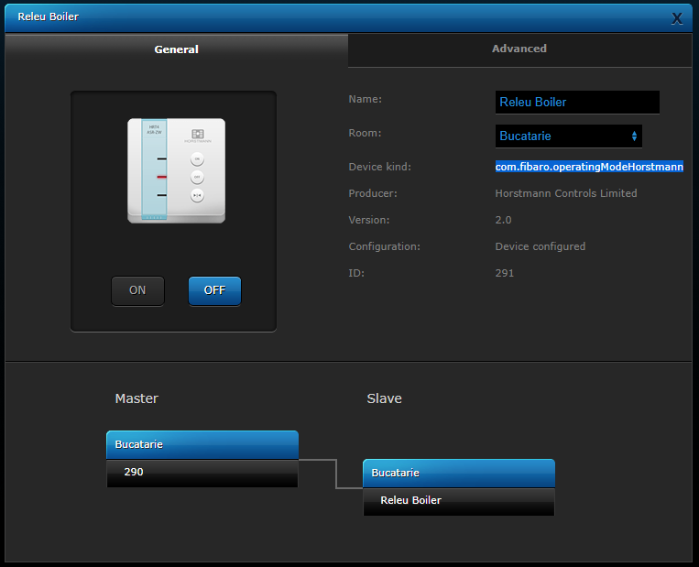

com.fibaro.operatingModeHorstmann

And as you can see, is assigned as Thermostat (maybe it is??):

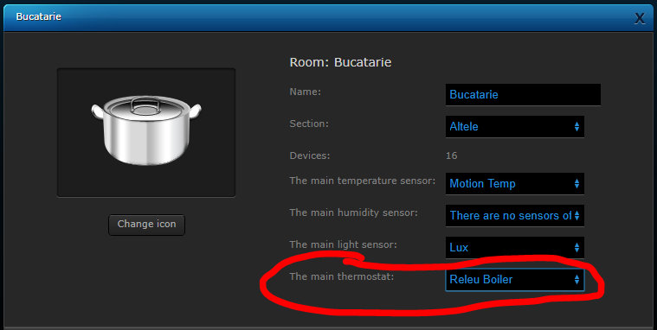

But in fact it is also ON/OFF switch... This ID (291) is set as "local boilerSwitch"

It is working OK now (after exclusion from network and reinclusion)

- Quote
- 4 weeks later...

rjd223
- Newbie

- 0
- 3 posts
- United Kingdom
- Gateway/s: Home Center 2

Posted April 26, 2018
Hi there,

Thank you so much for sharing this!

I have a quick question hopefully you may be able to answer.

My boiler switch is a Fibaro Dual Switch 2 (the ID on my system is 129). The scene runs but doesn't turn the switch On or Off. I've tried changing to "value" instead of "mode" and also tried changing "1" to "TurnOn" and a few others but cannot get it to work.

Do you have any idea what the correct coding would be for the Fibaro Dual Switch 2?

Many thanks in advance!
Rick.

- Quote

Dave_H
- Learner
- Topic Author
- 50
- 158 posts
- UK
- Gateway/s: Home Center 2
- Author

Posted April 29, 2018
Hi @rjd223

I believe that most switches would respond to commands such as this:

fibaro:call(boilerSwitch, "turnOn")
fibaro:call(boilerSwitch, "turnOff")

The best way to find out is to select the device in the Devices List pane to the left of the scene. The example below shows where I've selected one of the switches in the Lounge. For that device you can then see a list of properties that are supported by that device, and at the bottom a list of actions. Select the appropriate action and it will be inserted into the code where you've positioned your cursor:

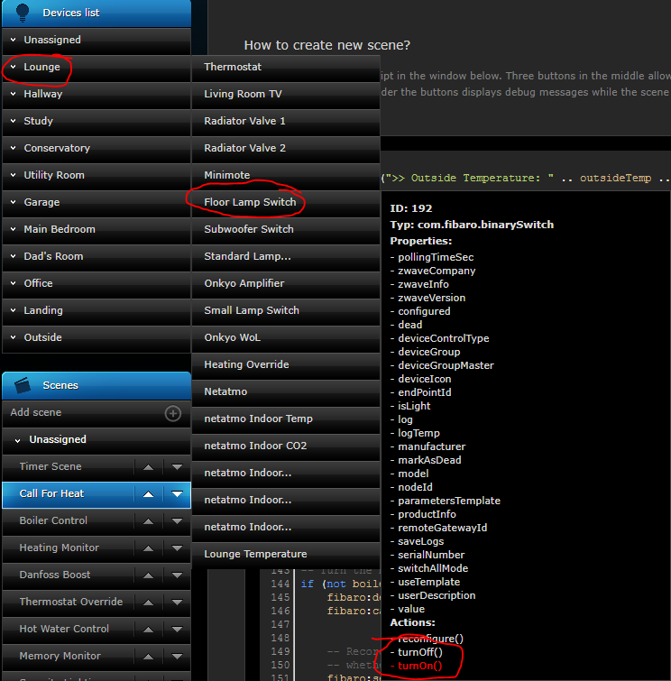

Dave

